**Bioengineering of Direct Cellular Reprogramming**

Kam W Leong*, Samuel Y Sheng Professor*

Departments of Biomedical Engineering | Columbia University | New York, NY 10027

Direct cell reprogramming, where differentiated cells are reprogrammed into another lineage without going through an intermediate stem cell-like stage, produces cells promising for regenerative medicine. It obviates the use of embryos and minimizes the risk of teratoma formation associated with the use of induced pluripotent stem cells. To facilitate eventual translation of transdifferentiation technologies we have demonstrated the feasibility of converting fibroblasts into neurons by nonviral overexpression of transcription factors. The poor conversion efficiency of nonviral direct cell reprogramming requires improvement. I will discuss our effort on using engineering strategies to optimize the biochemical and physical cues to enhance neuronal transdifferentiation. In particular, I will discuss the application of DNA nanoparticles to achieve direct conversion of fibroblasts into neuronal cells. I will also highlight the role of nanotopographical substrates in modulating the purity, conversion kinetics, and subtypes of the induced neurons generated by direct reprogramming. I will also discuss our recent effort on using CRISPR/dCas9 gene activation approach to achieve direct cellular reprogramming.

Adler AF, Grigsby CL, Kulangara K, Wang H, Yasuda R, and Leong KW. *Nonviral direct conversion of primary mouse embryonic fibroblasts to neuronal cells.* Mol Ther Nucleic Acid. 1: p. e32. (2012)

Kulangara K, Adler AF, Wang H, Chellappan M, Hammett E, Yasuda R, Leong KW. *The effect of substrate topo-graphy on direct reprogramming of fibroblasts to induced neurons.* Biomaterials. 35(20): p. 5327-36. (2014)

Chakraborty S, Ji H, Kabadi AM, Gersbach CA, Christoforou N, and Leong KW. *A CRISPR/Cas9-based system for reprogramming cell lineage specification.* Stem Cell Reports, 3(6): p. 940-7. 2014.

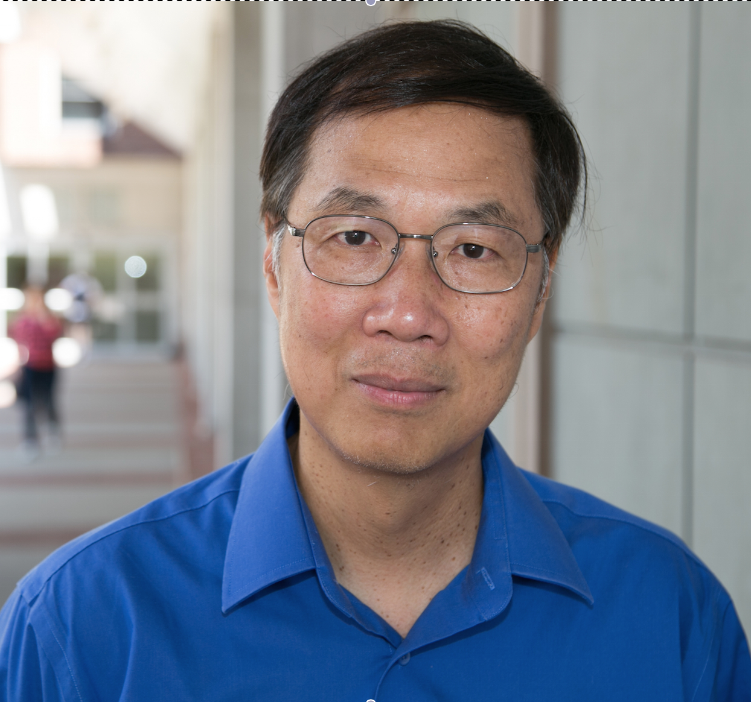Kam W. Leong is the Samuel Y. Sheng Professor of Biomedical Engineering at Columbia University. He received his PhD in Chemical Engineering from the University of Pennsylvania. After serving as a faculty in the Department of Biomedical Engineering at The Johns Hopkins School of Medicine for almost 20 years, he moved to Duke University in 2006 to focus on understanding and exploiting the interactions of cells with nanostructures for therapeutic applications. He has just joined Columbia University in September 2014. His lab works on nanoparticle-mediated nonviral gene delivery and immunotherapy, from design and synthesis of new carriers to applications for hemophilia and infectious diseases. The lab also works on the application of nanostructured biomaterials for regenerative medicine, particularly on understanding cell-topography interactions and on the application of nonviral vectors for direct cellular reprogramming. He has published ~300 peer-reviewed research manuscripts with citations exceeding 28,000, and holds more than 50 issued patents. His work has been recognized by a Young Investigator Research Achievement Award of the Controlled Release Society, Distinguished Scientist Award of the International Journal of Nanomedicine, and Clemson Award for Applied Research of the Society for Biomaterials. He is the Editor-in-Chief of *Biomaterials*, a member of the National Academy of Inventors, and a member of the USA National Academy of Engineering.